ABOUT LARISSA MILLER, HER POETRY AND PROSE

Larissa Miller was born on 29.03.1940 in Moscow where she has lived all her life. The author of 16 books of poetry and prose, two in English:  - the book of autobiographical essays Dim and Distant Days, Glas, 2000, translated by Kathleen Cook & Natalie Roy;  - the bilingual book of poetry Guests of Eternity, Arc Publications, 2008, translated by Richard McKane, Introduction by Sasha Dugdale (Poetry Book Society Recommended Translation).  A member of the Union of Russian Writers since 1979, and of the Russian Pen-Centre since 1992, Larissa Miller was shortlisted in 1999 for the State Prize of the Russian Federation, having been nominated for the prize by the famous literary almanach Novyi Mir: “Larissa Miller's poetry is a bright piece of triumph of the Russian speech and of the Russian classical poetry with its exact rhyme, laconicism, with its Pushkin's, Tyutchev's, Fet's enigma. We do not know why this poetry is never out of date, but this is a happy fact of Russian culture, its inalienable wealth. Larissa Miller continues this tradition today…” – from the Novyi Mir Presentation – http://magazines.russ.ru/novyi_mi/redkol/miller/hodat.html.  From Reviews to Guests of Eternity:  Charles Bainbridge (The Guardian, 18 April 2009): These concise, delicate poems, translated with impressive lightness of touch from the Russian, relish the small-scale, the fragile: "be quiet and white, white and quiet / at least between the lines, between the work". They celebrate moments of safety, of exhilaration, when the grander structures, the larger mechanisms of history and politics seem momentarily cast aside.  Written from the 1960s through to the 90s, Miller's poems are remarkable for their directness and apparent simplicity: "Everything happened that could / and which it was impossible to believe"… The writing throughout, however, is sustained by an optimism, a determination to find possibilities, no matter how faint and elusive, beyond the constant sense of danger.  Wendy Muzlanova (Scotland-Russia Forum Review, # 21, June 2009): It is a challenge to affix a particular style to Miller’s writing, so let’s not. We have here the physical, the metaphysical, the monotheistic and the pantheistic… Throughout this book, Richard McKane has done a wonderful job of translating Miller’s words, but if the English translation is able to stir your emotions, then Miller’s original Russian will rend them… | 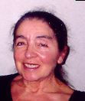  In 2004 a complete collection of Larissa Miller’s 800 poems for 40 years was published, (Moscow, Vremya Publ. – http://www.larisamiller.ru/gde_e.html) and after that 4 more books came out.  Besides the nostalgic “Childhood in Post-War Moscow”, “Romance with English” etc. published in Dim and Distant Days Larissa Miller wrote the stories “Heroines of Unwritten Novels”, “Dahin, dahin”, Reminiscences about her elder friend poet Arseny Tarkovsky (http://www.larisamiller.ru/yesli.html) and essays about her favourite authors: Vladislav Khodasevich, Vladimir Nabokov, Georgy Ivanov and again Arseny Tarkovsky (in the book “Poems and about Poems”, Glas, 1996 – http://www.larisamiller.ru/stiost.html).  Larissa Miller graduated from the Institute of Foreign Languages in Moscow and for many years has being working as a teacher of English, also since 1980 she has been teaching a women’s musical gymnastics system named after its creator, the renowned Russian dancer Ludmila Alexeyeva (who died in 1964 and whose only Obituary was published in London).  Oh, I believe in yesterday.  Beatles  They were singing ‘Yesterday’,  singing it on the long waves, /  singing ‘Yesterday’ ravishingly, /  and those beams flared that had long ago burned down. /  They were singing that wonderful song about those times, /  half-ghostly, it was heavenly there, /  where the beams flare and  never burn out./  Let our memory preserve that  likeness of paradise /  from which we can’t ever be  thrown out.  (Transl. Richard McKane)  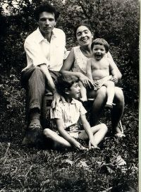  Larissa Miller with her husband and  two sons, Moscow, 1976 | Married in 1962, two sons. Her husband Boris Altshuler – a physicist and dissident, Andrei Sakharov’s close associate, at present working in the Physical Institute of the Russian Academy of Sciences and Chairing the “Right of the Child” NGO. I think that entering this family where conscience was the highest value was most important for Larissa’s development who began writing poems soon after her marriage, – Evgeny Evtushenko in his recent essay about Larissa Miller (Novye Izvestiya, 21 August 2009 – http://www.newizv.ru/news/2009-08-21/113499/).  More about Larissa Miller’s life and her views one can see in her recent English-language interview to Ruth O'Callaghan http://www.larisamiller.ru/introc.html (ROC: To what degree is it possible for poetry to effect political change? LM: When in the early 19th century Alexander Pushkin wrote: “We’ll entertain the good people / By strangling at the pillory / The very last tsar / With the last priest’s guts,” this was not the cause of the Russian revolution, which happened 100 years later in 1917, although the revolution literally did just that. On the other hand, another great Russian poet, Fyodor Tyutchev said: “We are not destined to foresee what consequences our words may have…”).  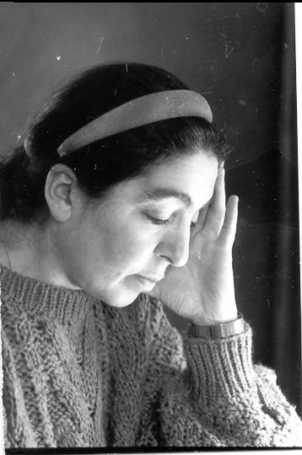  Larissa Miller  Between the cloud and the pit,  betwixt the birch and the aspen,  between the best of life  and the completely unbearable  under the high vault of the sky  the unstoppable swings  between Bosch’s freaks  and Botticelli’s spring.  (Transl. Richard McKane)  http://www.larisamiller.ru/english.html  baltshuler@yandex.ru

